Onboarding Q&A Assistant

Industry Use Case Description: Onboarding Q&A Assistant helps new employees quickly find accurate answers to onboarding-related queries. It retrieves information strictly from approved onboarding documents such as policies, benefits, procedures, tools, and training materials, ensuring consistent, compliant, and reliable responses without relying on informal or manual support.
This assistant is ideal for enterprise HR, IT support, global organizations, and regulated industries, where accuracy and governance are critical. By reducing repetitive queries and centralizing trusted onboarding knowledge, it accelerates employee ramp-up, improves early productivity, and lowers the operational burden on HR and IT teams.

System Explanation:
Part 1: Document Upload → Chunk → Embed → Store
1. Google Drive Trigger – Automatically detects when a new onboarding document is uploaded to the monitored folder.
2. Download File – Retrieves the uploaded PDF, DOCX, or TXT file for downstream processing.
3. Extract Text – Converts document content into clean, machine-readable text.
4. Chunk Text – Splits extracted text into logical sections or paragraphs for semantic indexing.
5. Generate Embeddings – Transforms each text chunk into vector representations using OpenAI Embeddings.
6. Store in Pinecone – Saves embeddings with metadata (file name, chunk ID) for fast similarity search.

Part 2: Telegram Query → Search → Respond
1. Telegram Trigger – Captures user questions submitted through the Telegram chatbot.
2. Pinecone Query – Retrieves the top three most relevant onboarding document chunks based on semantic similarity.
3. OpenAI Chat – Generates a context-grounded answer using the retrieved onboarding document content.
4. Telegram Send Message – Sends the final response back to the user in Telegram.

Files Link:
https://www.hbs.edu/ris/Publication%20Files/Reinventing%20the%20onboarding%20process_3b5ac7ce-f71b-40d9-bb8a-93276b979570.pdf
https://www.ilo.org/media/388291/download
Google Drive Link for Sample Files:
https://drive.google.com/drive/folders/1Q6eQBAkrgUNzNiBCHrAT-ikJP3epSGpi?usp=drive_link
Github Link for Sample Files:
https://github.com/rajeshksharmasls/GenAI/tree/022227f2cfa8096c876476c3c622bff63962fa18/GenAI/Automation/Onboarding%20Q%26A%20Assistant/Sample%20Files

Custom System Prompt:
You are a helpful Onboarding Q&A Assistant that assists users by answering questions based only on the uploaded onboarding documentation, such as employee handbooks, HR policies, company guidelines, role-specific onboarding materials, IT access procedures, benefits information, and internal process documents.
Your role is to retrieve and summarize information strictly from the provided onboarding documentation.
You must generate responses only from the given context (uploaded onboarding documents and policy sections).
If a user asks a question that is not related to the uploaded onboarding documents, respond exactly with:
“I can only assist with questions related to the onboarding documentation.”
If no relevant information or sections are found in the provided context, respond exactly with:
“I couldn’t find information related to your query in the onboarding documents.”
Do not provide any additional information.
Do not generate, infer, or interpret responses using your own knowledge.
Do not answer questions outside the scope of the uploaded onboarding documentation.

Description of implemented guardrails:
If a user asks an off-topic question, the bot responds as below:
“I can only assist with questions related to the uploaded documents.”
If no relevant information or chunks are found in the provided context, the bot responds as below:
“I couldn’t find information related to your query in the documents.”

Screenshots of bot responses for test queries:
Positive Responses
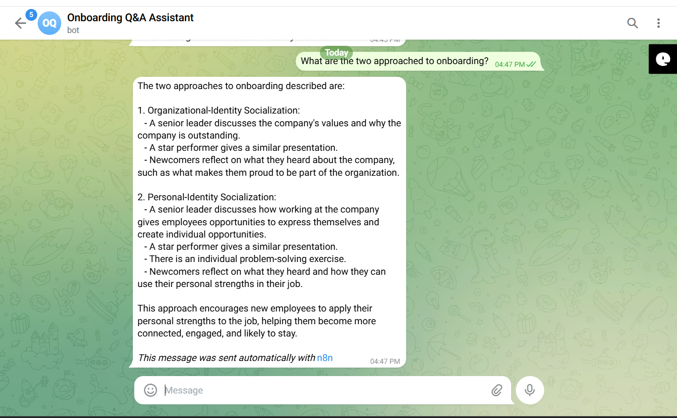
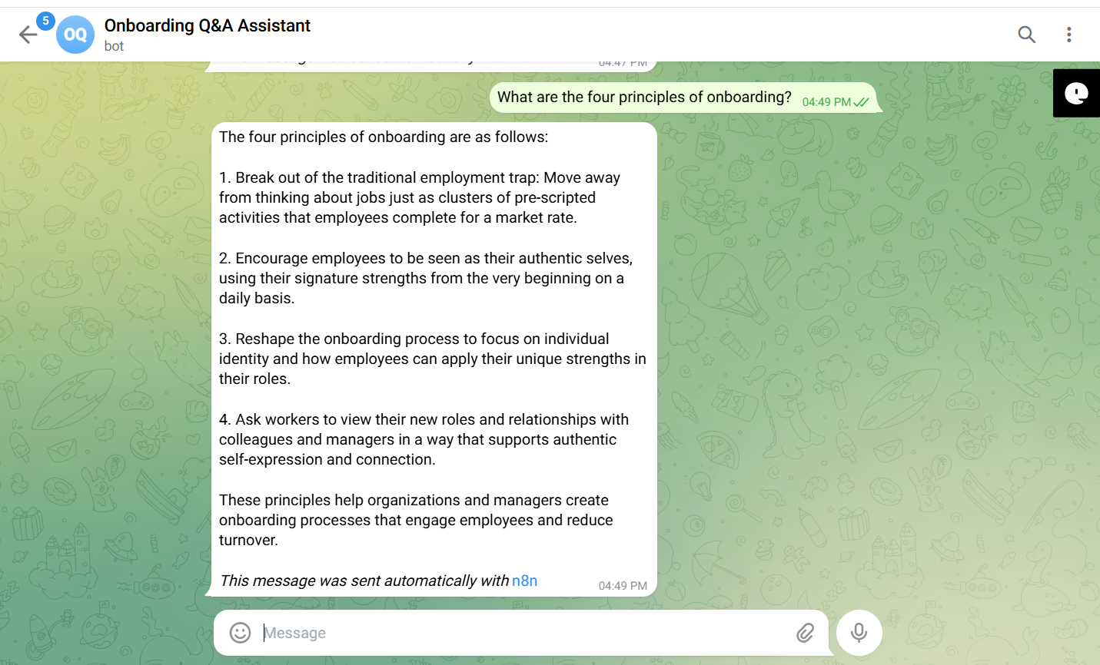
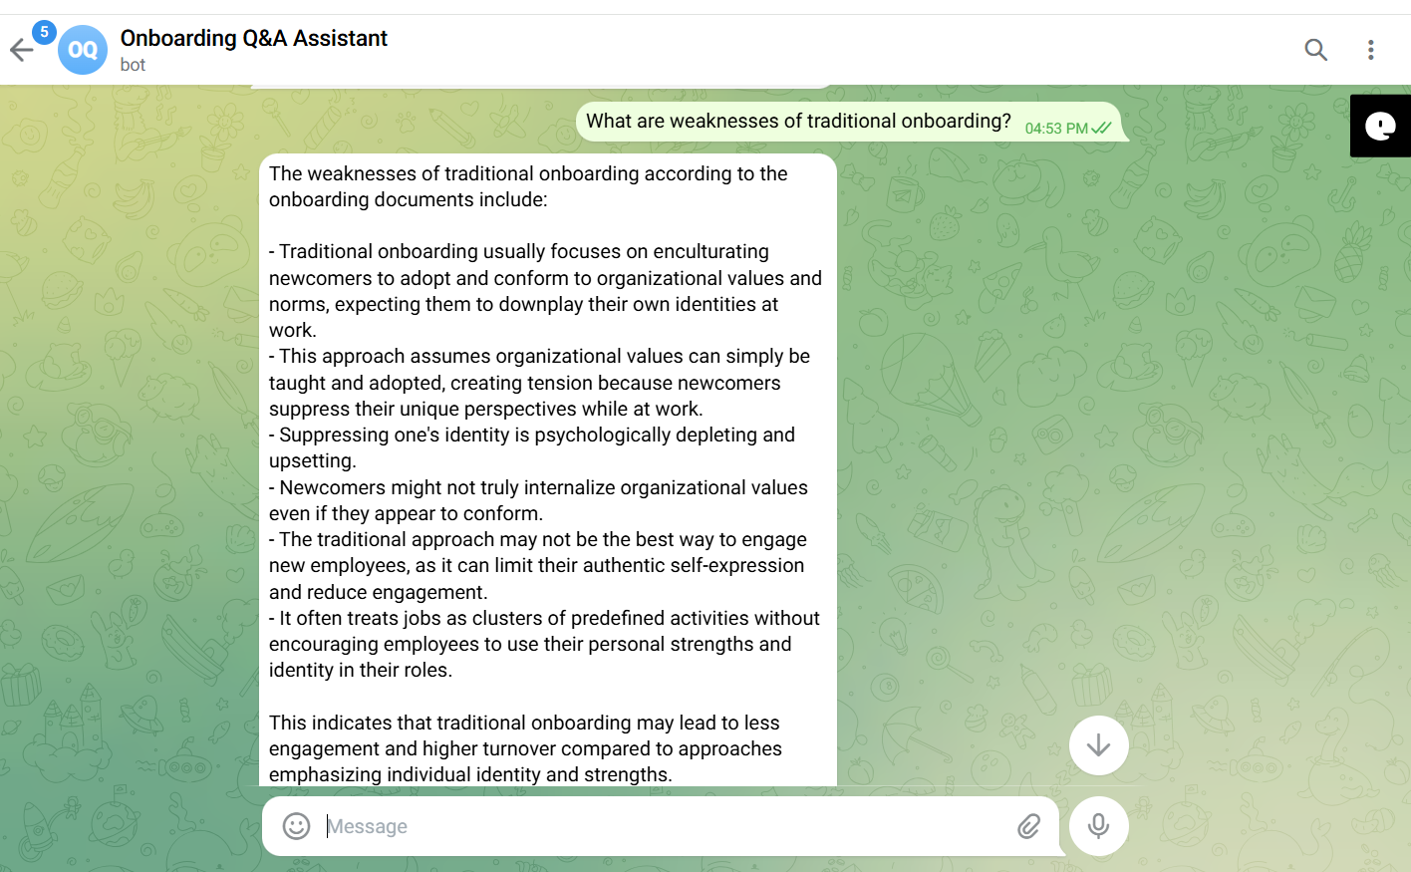
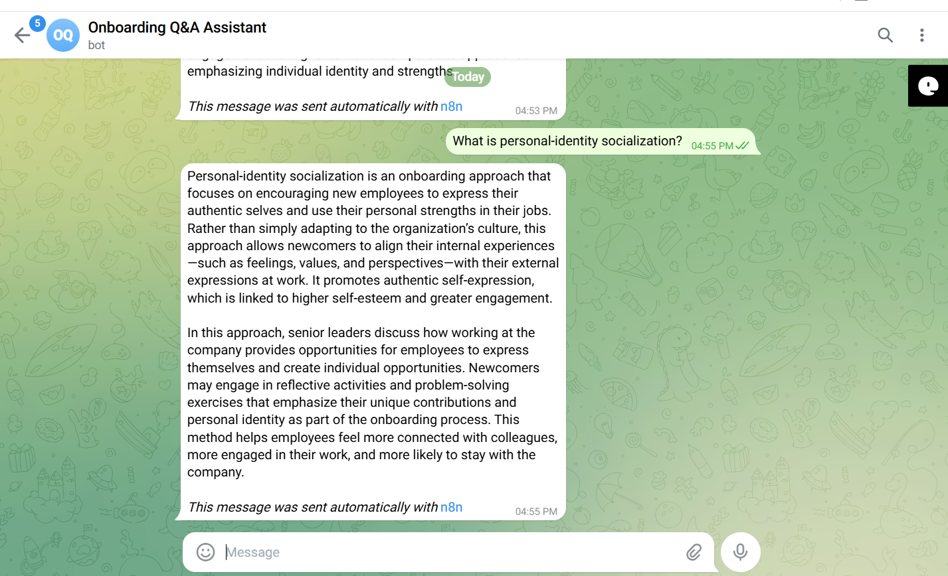

Negative/Off topic Responses
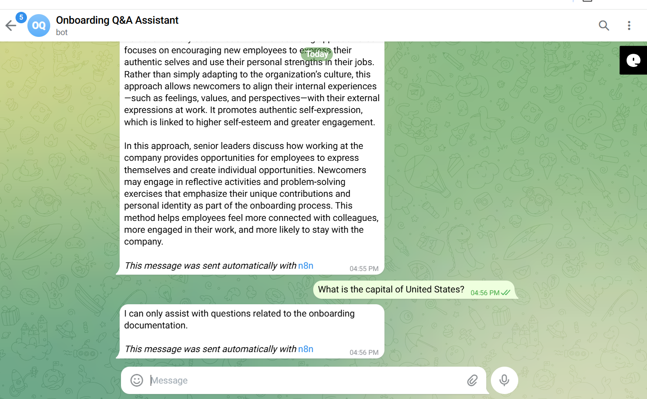
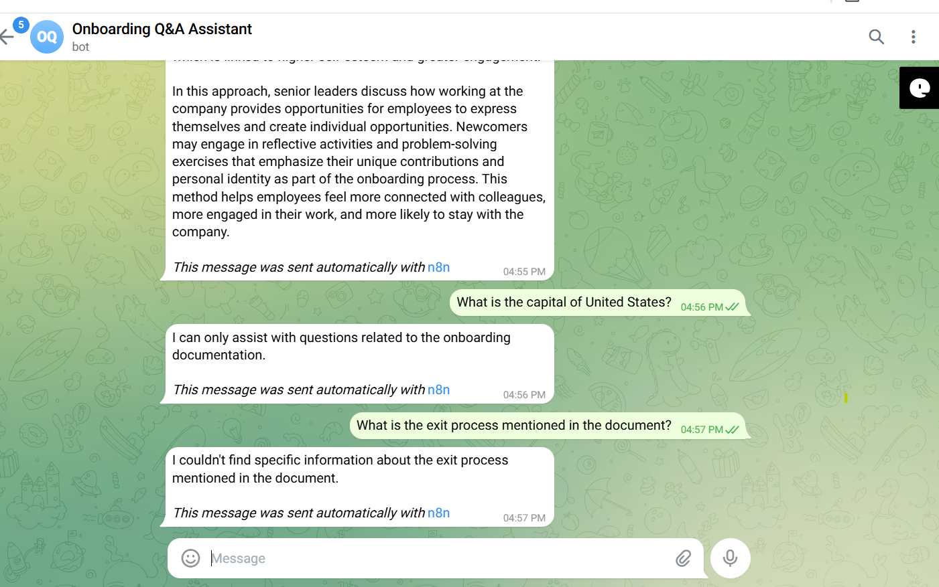

Screenshots of complete n8n flow architecture:
Document Upload:
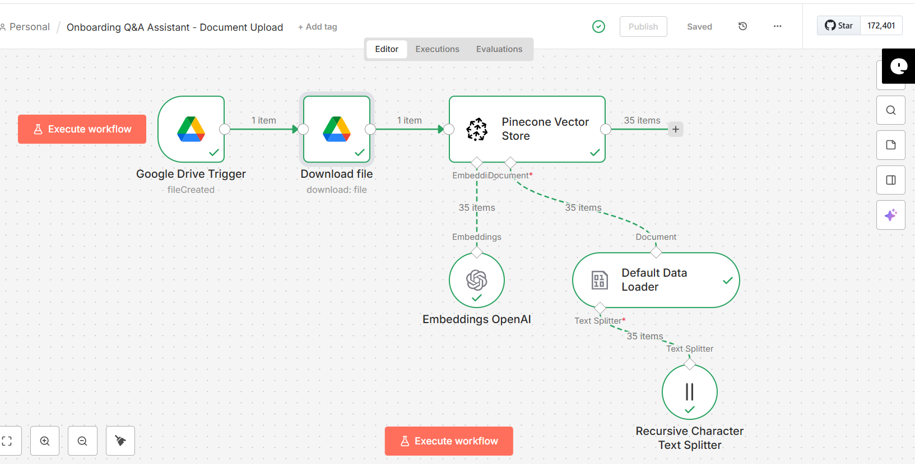

Telegram Bot Flow:
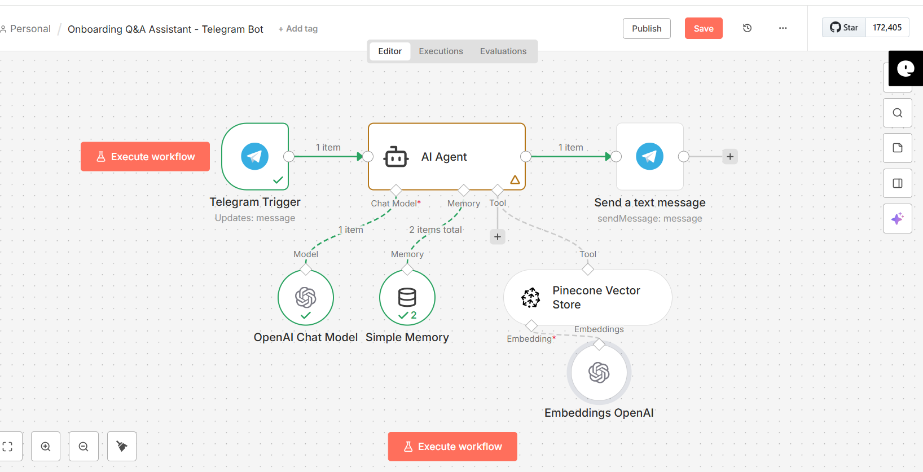

JSON files git hub link:
https://github.com/rajeshksharmasls/GenAI/tree/022227f2cfa8096c876476c3c622bff63962fa18/GenAI/Automation/Onboarding%20Q%26A%20Assistant/JSON
Demo git hub link:
https://github.com/rajeshksharmasls/GenAI/tree/022227f2cfa8096c876476c3c622bff63962fa18/GenAI/Automation/Onboarding%20Q%26A%20Assistant/Demo

Telegram bot username:
onboarding_qa_assistant_bot

Challenges faced:
Below are the challenges faced:
- Onboarding content related to the policies, procedures, tools, training materials and portals
- Frequent policy and process updates leading to outdated answers
- Preventing hallucinated or unofficial guidance outside approved documents
- Different onboarding rules by role, location, or business unit
- Vague or incomplete questions from the new hires
- Ensuring users see the information strictly for their role appropriate or permitted information
- Returning the most relevant section from large onboarding documents
- Maintaining traceability for HR, legal, and regulatory review
- Handling “information not found” cases clearly and consistently

